Berka Database Deep Analysis
REGION ANALYSIS · MONEY FLOW · LOAN SUITABILITY INDEX

OVERVIEW
This project continues work on the Berka database, previously explored in an earlier study. Here, the focus narrows to three specific aspects of the bank for deeper exploration and analysis: region, money flow, and loan.
For each aspect, the approach follows the same process: pick specific, meaningful questions, prepare the data needed to answer them, apply mathematical and statistical methods to explore the questions, and extract insights that support decision-making and help optimize how the system operates.
THE DATA & METHODOLOGY
Data was sourced from CSV exports of the Berka database used in the earlier study, and by connecting directly to the database to extract specific tables as needed. All analysis was performed in Python (Google Colab).
For each aspect this report covers the same structure: state the objective and the guiding questions, the data preparing and analyzing process, then interpret the results.
REGION ASPECT
Why this aspect?
Where the bank's accounts sit geographically, and what the client relationship looks like within each region, is not a neutral fact — it shapes branch investment, staffing, and marketing spend. Before regional strategy leans on that pattern, the pattern itself needs to survive a real test: is the signal worth acting on, or is it noise that a larger sample would smooth away.

Question 1
Is regional account distribution driven by chance, or do specific regions carry a genuinely higher share of the bank's presence?

ASSUMPTION
- H0: Account distribution is uniform across all regions.
- H1: Distribution is not uniform — regional factors are at work.
DATA
The full account base — 4,500 accounts — grouped into the bank's eight operating regions.
ANALYSIS
A chi-square goodness-of-fit test, comparing each region's observed share of accounts against the share an even, chance-only distribution would produce, with 95% confidence intervals built around each region's observed percentage.
RESULTS
The test was statistically significant with a chi-square statistic of 294.86 against a p-value of 7.56 × 10⁻⁶⁰ — The accounts are NOT evenly spread out by chance.

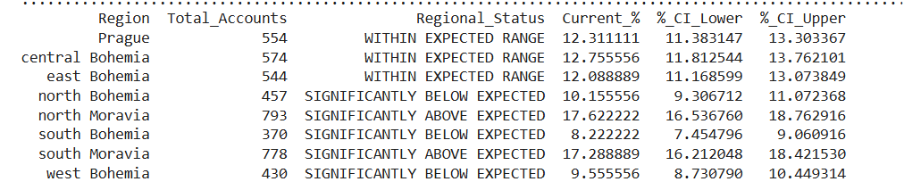

INTERPRETATION
The null hypothesis doesn't survive this test. Two regions carry a real, structural overweight in the bank's account base; three carry a genuine underweight; the remaining three sit almost exactly where an even distribution would place them.
INSIGHT
Regional concentration isn't a statistical illusion — North and South Moravia are, in a measurable and repeatable sense, the bank's strongholds.
Question 2
Which regions show the highest demand for the bank's services?
ASSUMPTION
- H0: penetration rate is uniform across all regions.
- H1: Penetration rate varies meaningfully by region.
DATA
Each region's accounts count set against its own totals for the bank's five order categories — utility, loan, leasing, insurance, and other — so that demand is measured as a rate within each region, not a raw count.
ANALYSIS
A chi-square test of independence, run separately for each of the five order categories.
RESULTS
- Utility — χ² = 12.70, p ≈ 0.08 — no significant difference across regions.
- Loan — χ² = 2.75, p ≈ 0.91 — no significant difference.
- Leasing — χ² = 6.87, p ≈ 0.44 — no significant difference.
- Insurance — χ² = 5.36, p ≈ 0.62 — no significant difference.
- Other — χ² = 9.02, p ≈ 0.25 — no significant difference.
INTERPRETATION
No order category shows a real regional preference. A client in North Moravia is no more or less likely to carry a loan, a leasing contract, an insurance policy, or a utility order than a client in any other region.

INSIGHT
The regional imbalance found in Question 1 has nothing to do with what clients need — demand itself is uniform nationwide.
Question 3
Do regions differ in monthly financial behavior, measured as average monthly net balance (B/M)?

ASSUMPTION
- H0: Monthly net balance is identical across all regions.
- H1: At least one region differs significantly from the rest.
DATA
Average monthly net balance (B/M) computed for all 4,500 accounts and grouped by region.
ANALYSIS
A Kruskal-Wallis test — the non-parametric counterpart to one-way ANOVA, chosen because monthly net balances are not normally distributed.
RESULTS
H-statistic = 1.88, p ≈ 0.966. — no significant difference.
INTERPRETATION
There is no evidence that any region’s monthly financial behavior differs from any other. The regional medians are, for all practical purposes, identical.
INSIGHT
Client’s financial behavior is the same regardless of where they are.

KEY INSIGHT— Region
The regional imbalance of accounts is real and statistically defensible: North and South Moravia are, in a measurable and repeatable sense, the bank’s strongholds. However, this imbalance has nothing to do with what clients need; instead, it is likely tied to historical branch placement or market entry timing.
Client’s characteristics are identical across all regions, both service demand and financial behavior remain strictly uniform nationwide.

MONEY FLOW ASPECT
Why this aspect?
Once we understand who our clients are, we can look at the core of banking, which relies on a simple cycle: clients deposit money, withdraw money, and leave a portion behind. To evaluate the health of this cycle, we must analyze this flow from a high-level, bank-wide perspective on a monthly basis.
This analysis allows us to monitor how much capital enters the system, how much flows out, how much remains stable within the accounts, and how much the bank successfully captures as revenue. By mapping this continuous movement of funds, we gain a clear, macro-level view of the bank's liquidity and overall financial performance. Therefore, we will reconstruct the bank's approximate monthly cash flow by standardizing its full transaction history to a monthly average at the bank level.

The Calculation Methodology
The full transaction history was standardized to one representative average month, at the level of the bank as a whole. Outflow was then split into what the bank itself retains — fees and loan repayments — and what continues on to clients untouched. The result was visualized as a Sankey flow diagram (Plotly), tracing inflow into outflow, and outflow into its two destinations: the bank and the client.

Results
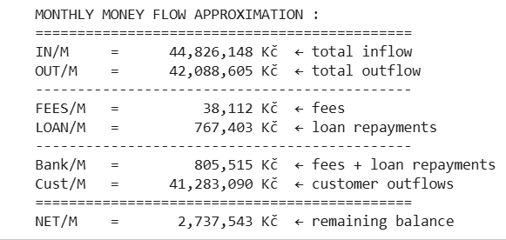
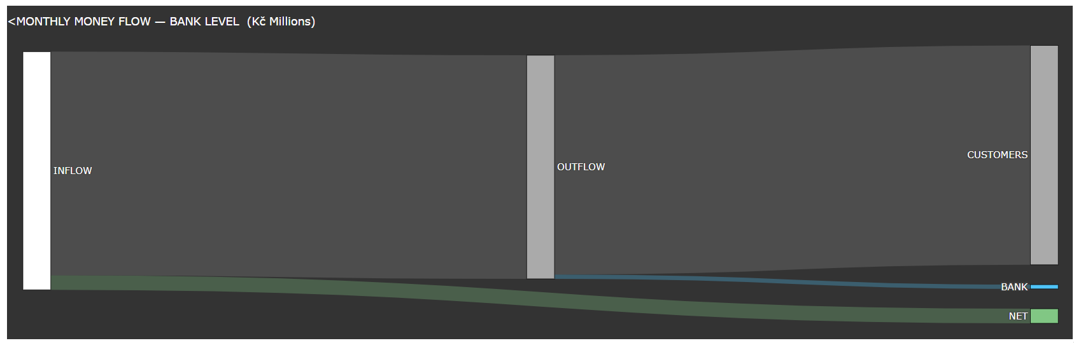

KEY INSIGHT — Money Flow
On average, 44.8M Kč flows into the bank monthly and 42.1M Kč flows out. Of that total outflow, only 805K Kč—fees plus loan repayments — is kept by the bank itself, while 41.3M Kč passes straight back through to the clients. Ultimately, the bank retains roughly 1.8% of the capital moving through its system each month, demonstrating that it functions far more as a transactional channel for its clients' money than as a direct beneficiary of it.
LOAN ASPECT
Why this aspect?
Loan decisions directly affect the bank's risk exposure and profitability. Understanding which accounts are genuinely suitable for a loan — beyond a simple approval/rejection — provides a consistent, evidence-based way to support that decision.
Objective
Identify which bank accounts are suitable for a loan, based on their historical financial behavior.
By doing so, this analysis provides a clear, data-driven understanding of what things truly matter when granting a loan.
Data
For this analysis, I reconstructed two distinct data tables:
- The All-Accounts Table: A table containing all the accounts in the bank along with their complete historical financial behavior.
- The Pre-Loan Table: A table specifically for the accounts that had been granted a loan, where their historical financial behavior was entirely recalculated using only the period before their loan date.
Methodology
The assessment is built on two independent layers:
LAYER 1 — CAPACITY FILTER
For a standard loan (amount and duration adjustable), calculate whether the account's average monthly net balance can mathematically cover repayment.
- H0: Account cannot mathematically repay
- Threshold: R ≥ 1.2
LAYER 2 — QUALITY INDEX
Five candidate variables, each representing a distinct dimension of account behavior, were tested on 682 accounts with known loan outcomes, using logistic regression to measure each variable's real, independent effect on the outcome.
- Income retention → I
- Consistency → CV
- Tenure with the bank → P (months)
- Life stage → Age
- Financial trend/direction → Slope

ANALYSIS
1. VARIABLE PREPARATION
Each variable was examined for its distribution shape (skew, outliers, range) before transformation, and scaled according to what its shape and meaning required: standard scaling for symmetric variables, log-transform plus scaling for right-skewed ratios, and clipping plus robust scaling for variables with severe outliers. Age was modeled using a domain-informed plateau function reflecting financial life-stage stability, rather than a simple linear scale.
2. SIGNIFICANCE TESTING
A logistic regression was fitted on the 682-account sample, cross-checked with a Random Forest model for independent confirmation.
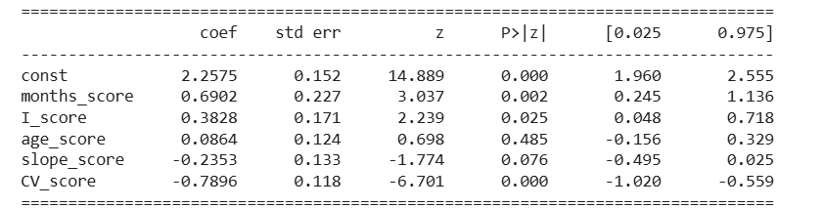
- CV : strongest, most consistent effect
- I : real effect
- Months (tenure) : real effect
- Slope : borderline, retained due to explanatory contribution
- Age : no statistically significant effect — excluded from the final model

The final model (months, I, slope, CV) achieved a Pseudo R² of 0.111 and a ROC-AUC of approximately 0.80
3. MODEL VALIDATION
Applying on the training sample, confirming genuine, if moderate, discriminative power. Good and bad accounts were confirmed to score correctly on opposite ends of the scale.
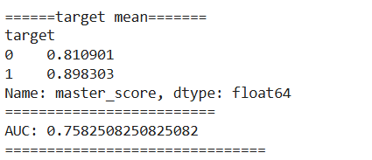
4. APPLYING THE MODEL TO THE FULL PORTFOLIO
A distribution comparison (Kolmogorov–Smirnov test) showed that most variables differ significantly between the 682-account training sample and the full 4,500-account portfolio. Applying the training sample's scaling to the full portfolio distorted the results (Population Stability Index = 0.737). Scaling each variable independently on the full portfolio's own distribution resolved this (PSI = 0.020), confirming the scores are safe and stable to use across the entire portfolio.
5. FINAL OUTPUT
Every account in the portfolio receives: a live capacity check (R, calculated per loan offer), a master suitability score (0–1, combining all four validated behavioral variables), and two independent, transparent rankings — Consistency (CV) and Income Retention (I) — each labeled Low, Medium, or High relative to the full account population.
KEY INSIGHT — Loan Suitability
Behavioral consistency (CV) is, by a clear margin, the strongest predictor of loan outcome in this data — more so than income retention, tenure, or financial trend. Age shows no measurable effect, even when modeled to reflect financial life-stage rather than raw age. The resulting index gives the bank a validated, explainable basis for prioritizing loan candidates, separate from and complementary to the pure capacity check.

